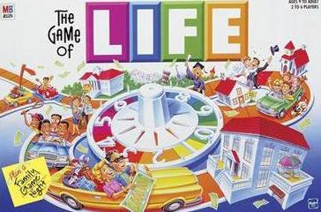
Name:_______________________
2nd Term Project: The Game of Life

MR. FARHAT

Purpose: This project was selected to address the needs for personal responsibility in LIFE. From deciding to go to college or immediately entering the work force, students will need to make decisions that impact their financial obligations. In this project students will be utilizing the structures of a board game to stimulate classroom discussion while providing personal growth opportunities as they work their way to retirement.
Overview: Most activities pertaining to the project will be implemented during classroom time, so it is very important that students are present during classroom instruction. Some important elements such as writing checks and keeping up with the registry are items of great importance and will further develop as the project is carried out throughout the term.

Grading Rubric:

- Participation | 10 points
- A complete paper to describe your dream job and how math would be applied | 25 points
- Writing a completed registry | 50 points
- Writing checks to match registry entries | 50 points
- 12 How Shopping Works: In the order given  15%, 10%, 23%, 5%, 7%, 20%, 25%, 50%, 10%, 45%, 12%, 35% | 10 points
- How Credit Cards Work (with pretend credit card) | 10 points
- The Cost of Living | 10 points
- Automobile Choice and Home or Apartment Choice | 10 points
- Three journal entries (minimum of three detailed sentences each) for events that occurred during the game | 25 points
Total: | 200 points

Due date: Dec 21st (this date is subject to change pending the completion of the game.

Bonus: Students have opportunity to gain bonus if they have everything typed (professional presentation of their project), they end up with the most money at the end of the game, and they finish first.

