Proceedings of the ASME 2012 International Mechanical Engineering Congress & Exposition
IMECE2012
November 9-15, 2012, Houston, Texas, USA
IMECE2012-86355

Embedding Project Based learning in high school STEM teaching to increase student interest and access to the curriculum

Phillip Moore  Fitchburg High School  Fitchburg, MA, USA | Jeremy Roche  Fitchburg High School  Fitchburg, MA, USA

Philip Curtin  Fitchburg High School  Fitchburg, MA, USA | Abe Zeid, Ph.D.  Northeastern University  Boston, MA, USA

Abstract
Fitchburg High School is an urban school located in Central Massachusetts. Fitchburg is a poor economic community with 65% of students receiving free and reduced lunch. The average class size is 25 students. Following the national trend, Fitchburg students lack the interest and motivation in STEM courses, especially in abstract courses such as physics. Thus, finding ways to make the curriculum accessible and interesting for our students is the key to accelerating their academic achievement. We hypothesized that embedding project based learning (PBL) would provide our students greater access and deeper understanding of the conceptual physics curriculum.
In our quest for a change, we attended a PBL professional development intensive summer workshop for two weeks offered by a local university and funded by NSF. The workshop introduced the Engineering Design Process (EDP) as the core of PBL. The workshop participants shared a similar interest in learning how they could create authentic classroom experiences that would require students to apply their knowledge as opposed to recite or parrot facts.
PBL is not new as many teachers utilize project work to extend the learning opportunities for students. However, PBL is usually done outside of the classroom, at home, and towards the end of the quarter of the school year. This presents a number of challenges for our students and diminishes the potential of PBL and often leads to poorly conceived and poorly executed projects. For example, many of our students find it difficult to complete these kinds of projects because of a lack of resources and support at home. More often than not, they do not present the opportunity for student revision and re-evaluation.
As teachers in an urban comprehensive high school, we decided to change the practice of assigning projects from out of school experiences to in the school, in the classroom experiences. It has been our contention that by embedding the project within the classroom experience and integrating the lesson as part of the project, students will have greater access to the content of and retention of the lesson. It also creates more opportunity for active learning and problem solving between students. . Students move forward on the hierarchy of learning when they are able to discuss their ideas and explain their reasoning for the ideas. Their investment in the project drives student interest and ownership of their work and behavior. It affords them control of their learning environment and challenges them to find understanding and application of the content in ways that are unique to them.
This paper will discuss the implementation of our project and how we embedded the EDP into our daily classroom environment in sophomore physics classes. We will describe the framework created to assist students in the design process and through the initial build phase. We will highlight the progression of student work and how the EDP process required reflection on their product, academic progress and comprehension of the physics involved in their build. We will also discuss the positive and negative reactions of the students to the non-traditional method of learning. We will also discuss the teachers’ observations of the experience. Lastly, we will discuss the effect that a project based learning model has on student behavior and engagement within the classroom.

Introduction
Fitchburg High School is an urban school located in Central Massachusetts. Fitchburg is a poor economic community that has lost most of its economic stability as the manufacturing moved south and then overseas. Following the national trend, Fitchburg students lack the interest and motivation in STEM courses, especially in abstract courses such as physics. Thus, finding ways to make the curriculum accessible and interesting for our students is the key to accelerating their academic achievement.
The school population is 1091. The average class size of 18.2 students per class. 69.3% of our school population is considered low income and 5% are ESL students. [Low income statistic for the district 73.5%] The demographic makeup of our school is listed in the table below. [1]

Enrollment by Race/Ethnicity [2012-13]
Race | % of School | % of District | % of State
African American | 9.4 | 5.8 | 8.6
Asian | 7.3 | 5.5 | 5.9
Hispanic | 40.2 | 44.6 | 16.4
Native American | 0.0 | 0.1 | 0.2
White | 39.7 | 38.2 | 66.0
Native Hawaiian, Pacific Islander | 0.1 | 0.1 | 0.1
Multi-Race, Non-Hispanic | 3.2 | 5.7 | 2.7

The students are required to take 4 years of science, 2 life sciences and 2 physical sciences. Students often struggle with the physical sciences because of mathematical and content language difficulties. They often lack variety context clues for content language acquisition. The typical course progression at FHS has our freshman students taking Biology, our sophomores taking Conceptual Physics while our juniors take chemistry and other elective offerings. Seniors have the freedom to enroll in a host of AP classes as well as lesser level electives.

The students find some aspects of the science curriculum difficult. They particularly struggle with the application of math and abstract ideas in science classes. As educators in an urban school district, it is incumbent upon us to try to find ways to make the curriculum accessible and interesting for our students. In our quest for new and interesting teaching methods, I attended a “CAPSULE” professional development intensive summer workshop for two weeks offered by a local university and funded by NSF.[2] The workshop introduced the Engineering Design Process [EDP] as the core of project based learning [PBL]. The workshop participants shared a similar interest in learning how they could create authentic classroom experiences that would require students to apply their knowledge as opposed to recite or parrot facts.

The authors hypothesized that by embedding project based learning [PBL] with in our class content, students would have greater access and a deeper understanding of the conceptual physics curriculum. The authors decided to change the practice of assigning projects from an out of school experience to in the school project. It was their hope that students would have greater access to the content of and retention of the lesson. It also creates more opportunity for active learning and problem solving between students. Students move forward on the hierarchy of learning when they are able to discuss their ideas and explain their reasoning for the ideas. Their investment in the project drives student interest and ownership of their work and behavior. It affords them control of their learning environment and challenges them to find understanding and application of the content in ways that are unique to them.
The physics teachers embraced the idea of imbedding project based learning into our daily activities. The lead teacher described the STEM based PD and the Capstone implementation project idea. We thought the idea was a good and that it could really help the students have a quality experience in science. In addition, the initiative was going to be in tune with the next generation science standards that promote the Engineering and Design process within the class room. “Learning about science and engineering involves integration of the knowledge of scientific explanations [i.e., content knowledge] and the practices needed to engage in scientific inquiry and engineering design. Thus the framework seeks to illustrate how knowledge and practice must be intertwined in designing learning experiences.”[3] The teachers involved in the project had 70 years of science instruction experience. With all of our teaching experience, the group knew that this was uncharted territory for us and would require flexibility and adaptability in the endeavor.

Planning and Implementation
The physics teachers met several times during the summer months to plan and coordinate the project deliverables. We chose to work on a single project for the first term as our focus for all of the 10th grade physics students. The project centered on the creation of a mouse trap powered car that could go 10 meters. Excitement grew as we discussed the idea and could imagine the possible experiences that the students would have. The authors envisioned kids in the hall ways testing their work while passersby would stop and ask them what they were doing. We hoped that the positive attention would create a synergy and excitement within the school community as the student’s creativity and achievement was noticed by their peers. It was clear that there would need to be a lot of scaffolding in place to help the students keep track of both their class work and completing the project goals. A first steps was to create a calendar for the students that connected the class room objectives with the project deliverables. We then created the project report and labs that would be assigned for their engineering note book.[4][5} Included in that note book was a journal format page and an outline of what was expected from the students. We knew that the students would need to have a solid background in what the EDP was and how it was applied to problem solving.

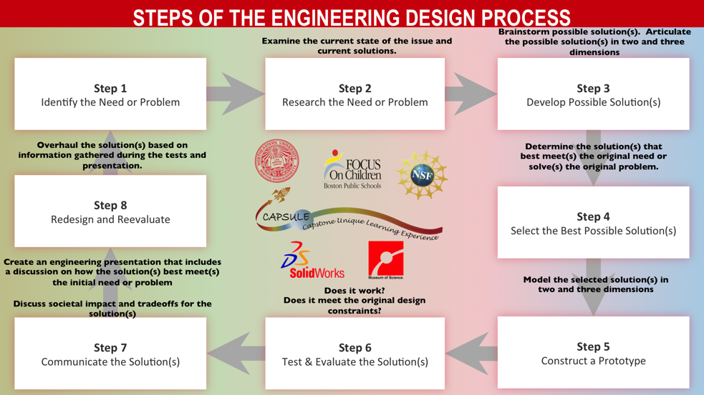

We started with an brief lesson on the EDP process followed by a directed brain storming activity that guided their immersion into the design process focusing on design considerations and concerns.[6] We created several lessons involving a group “think-pair-share” using their design considerations from the directed brain storming activity. That work resulted in a thorough analysis of the design and limited material concerns for the creation of any car that would succeed. It also forced the students to think critically about the strengths and weaknesses of the building materials and team members. Teachers provided technical assistance, encouragement and some counseling to groups when they encountered adversities or setbacks in achieving the goal. It was important for the teachers to discuss and model conflict resolution strategies and team building vocabulary and skills. The teachers also had to instruct students on the use of basic tools and building methods to ensure safety within the classroom.

The Building Phase
We provided the students milestones to reach along their journey. Those milestones measured their progress towards achieving the 10 meter goal and completion of their engineering notebook. They also forced students to think reflectively on their own work and the science guiding their design. A major hurdle for many of our students was limited insight and experience in building models and the use of building materials. Students demonstrated a disconnect with the functionality of the car parts as it related to the car’s performance. The teachers guided students through the problem solving process. We helped students connect performance issues with student observations of their car in action. This allowed the student to augment their deficits to achieving their goals. By focusing on improvements to their cars as it relates to the physics curriculum, improvements in performance were observed. The opportunity to build and design needed to be tempered with daily lessons on the application of related concepts within the curriculum. Their work with the cars was focused through that lens to make clear connections between design, product, performance and the curriculum. As a result, all most all of the students were able to reach the first milestone of having their car roll 5 meters off a shallow ramp and without the aid of a mouse trap. This ensured that the students had a working chassis with axles designed to harness the power of the mouse trap. It gave the students hands-on experience and understanding of the concept of inertia and friction as an outside force that impedes motion. This was followed by a larger reflective writing assignment that required students to explain how they used the EDP process to change their design to achieve the first milestone. Failure was not an option, students were counseled and encouraged redesign and remodel their work so that they achieved the project goal. This model of relating work and classroom was followed throughout the quarter as the project reached completion. The final student deliverable was a completed analysis of the car and an engineering notebook from their group.

Analysis and Discussion
Teachers and students had positive reactions to the non-traditional method of learning.
  - “The mouse trap car and project based learning model drove student interest while increasing engagement in the course topics. The project enhanced and augmented student motivation for the group as well as the individuals in the class.” [teacher]
  - “The whole was better than the sum of the parts. A lot of good discussion and ideas came up during the group process. Students found it overwhelming and powerful to think of and create something from scratch.” [teacher]
  - “I loved the car project and had fun doing it.” [student]
  - “This class has good activities such as the mouse trap car and the egg drop. That’s one of the best things about the class.” [student]
  - “Projects were good because we got to build stuff and test it afterwards.” [student]
  - “Projects were tons of fun, I really enjoyed doing them and having the freedom to choose my partner.” [student]
  - “I enjoyed doing the hands on activity. I feel I learn better when I can see and hold what’s going on. Math is hard and just talking about it doesn’t drive the point home.” [student]
  - “The activities were simple at times, but mostly hard. That is a good thing because I had to use my brain.” [student]

As can be seen from the quotes, the overall experience was positive. Students would enthusiastically anticipate the time for building during the week and would ask to have extra time for construction. There were many fun hallway conversations regarding interclass competition over whose car would go farthest.
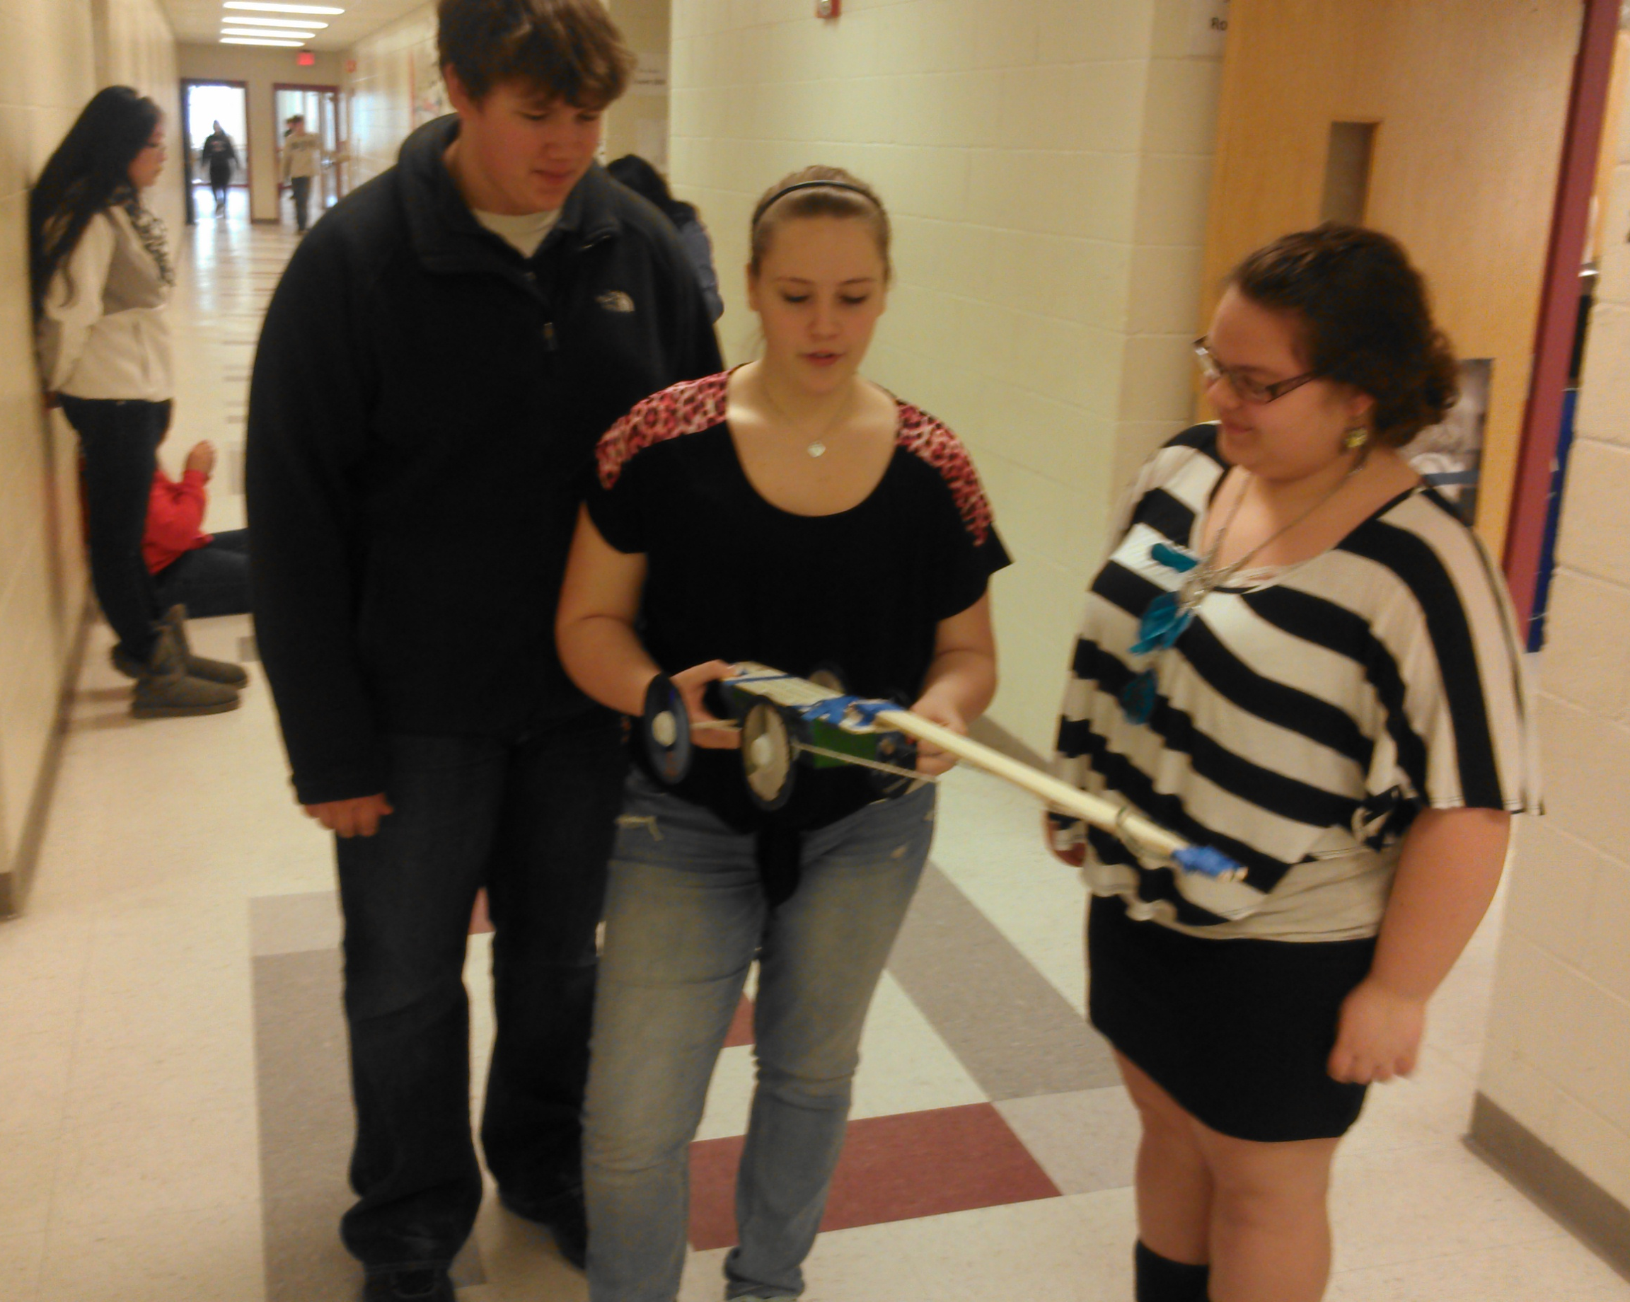Figure1 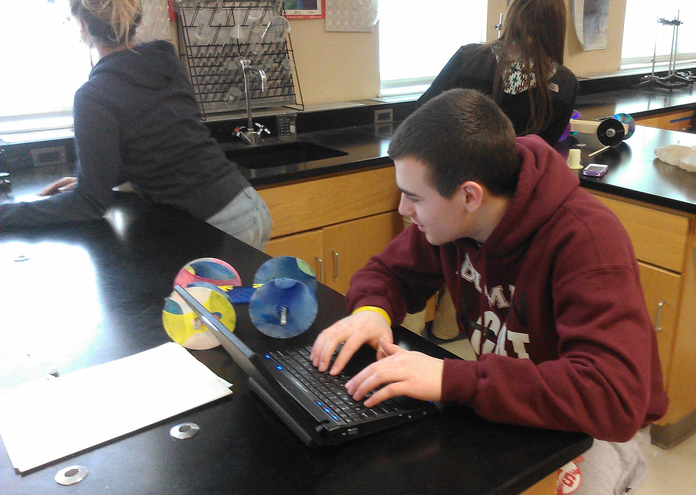 Figure 2

Figure3 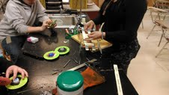 Figure 4

The teachers observed and appreciated the creative use of materials and student design as demonstrated in figures 5-9. Bottle caps, tissue boxes, skate board parts, fishing rods, lego’s, connects and scraps of wood were a few of the materials that were brought in for the build. The students demonstrated ownership of their work with the level of detail they applied to the design and the decore of the cars they built as seen in figures 5-9. I was particularly impressed with the use of the bottle caps as a way connecting the CD’s to the very narrow coat hangers they used for axles. Quite a bit of thought and redesign went into the creation of a properly alligned axle wheel system with those CD’s and coat hangers. The cars in figures 6 and 9 demonstrated an ingenious use of cotter pins and pen caps as a creative way of connecting their wheel systems to the chassy.

- 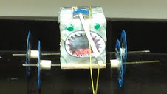 Figure 5 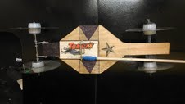 Figure 6
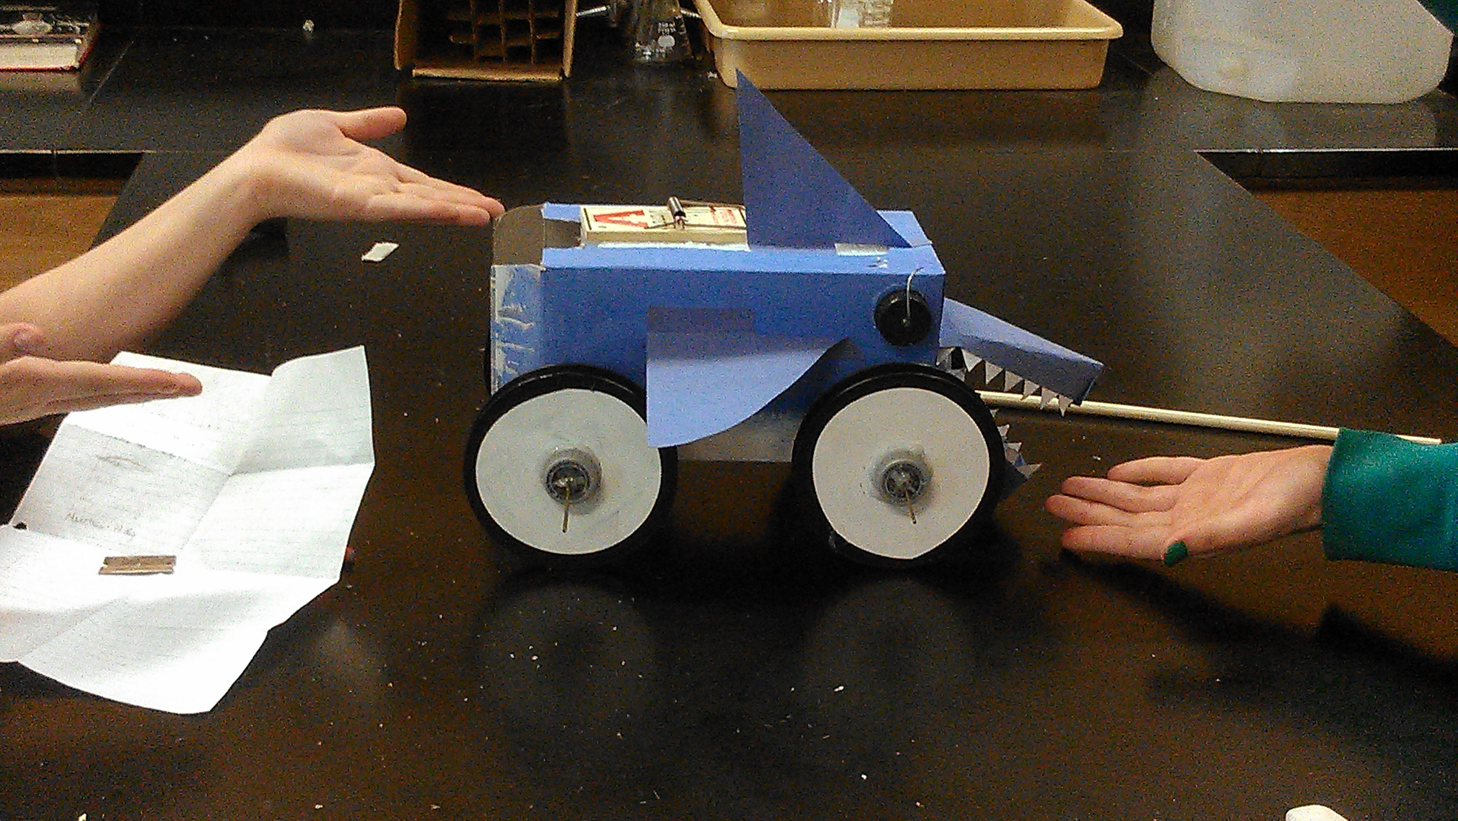 Figure7 Figure 8

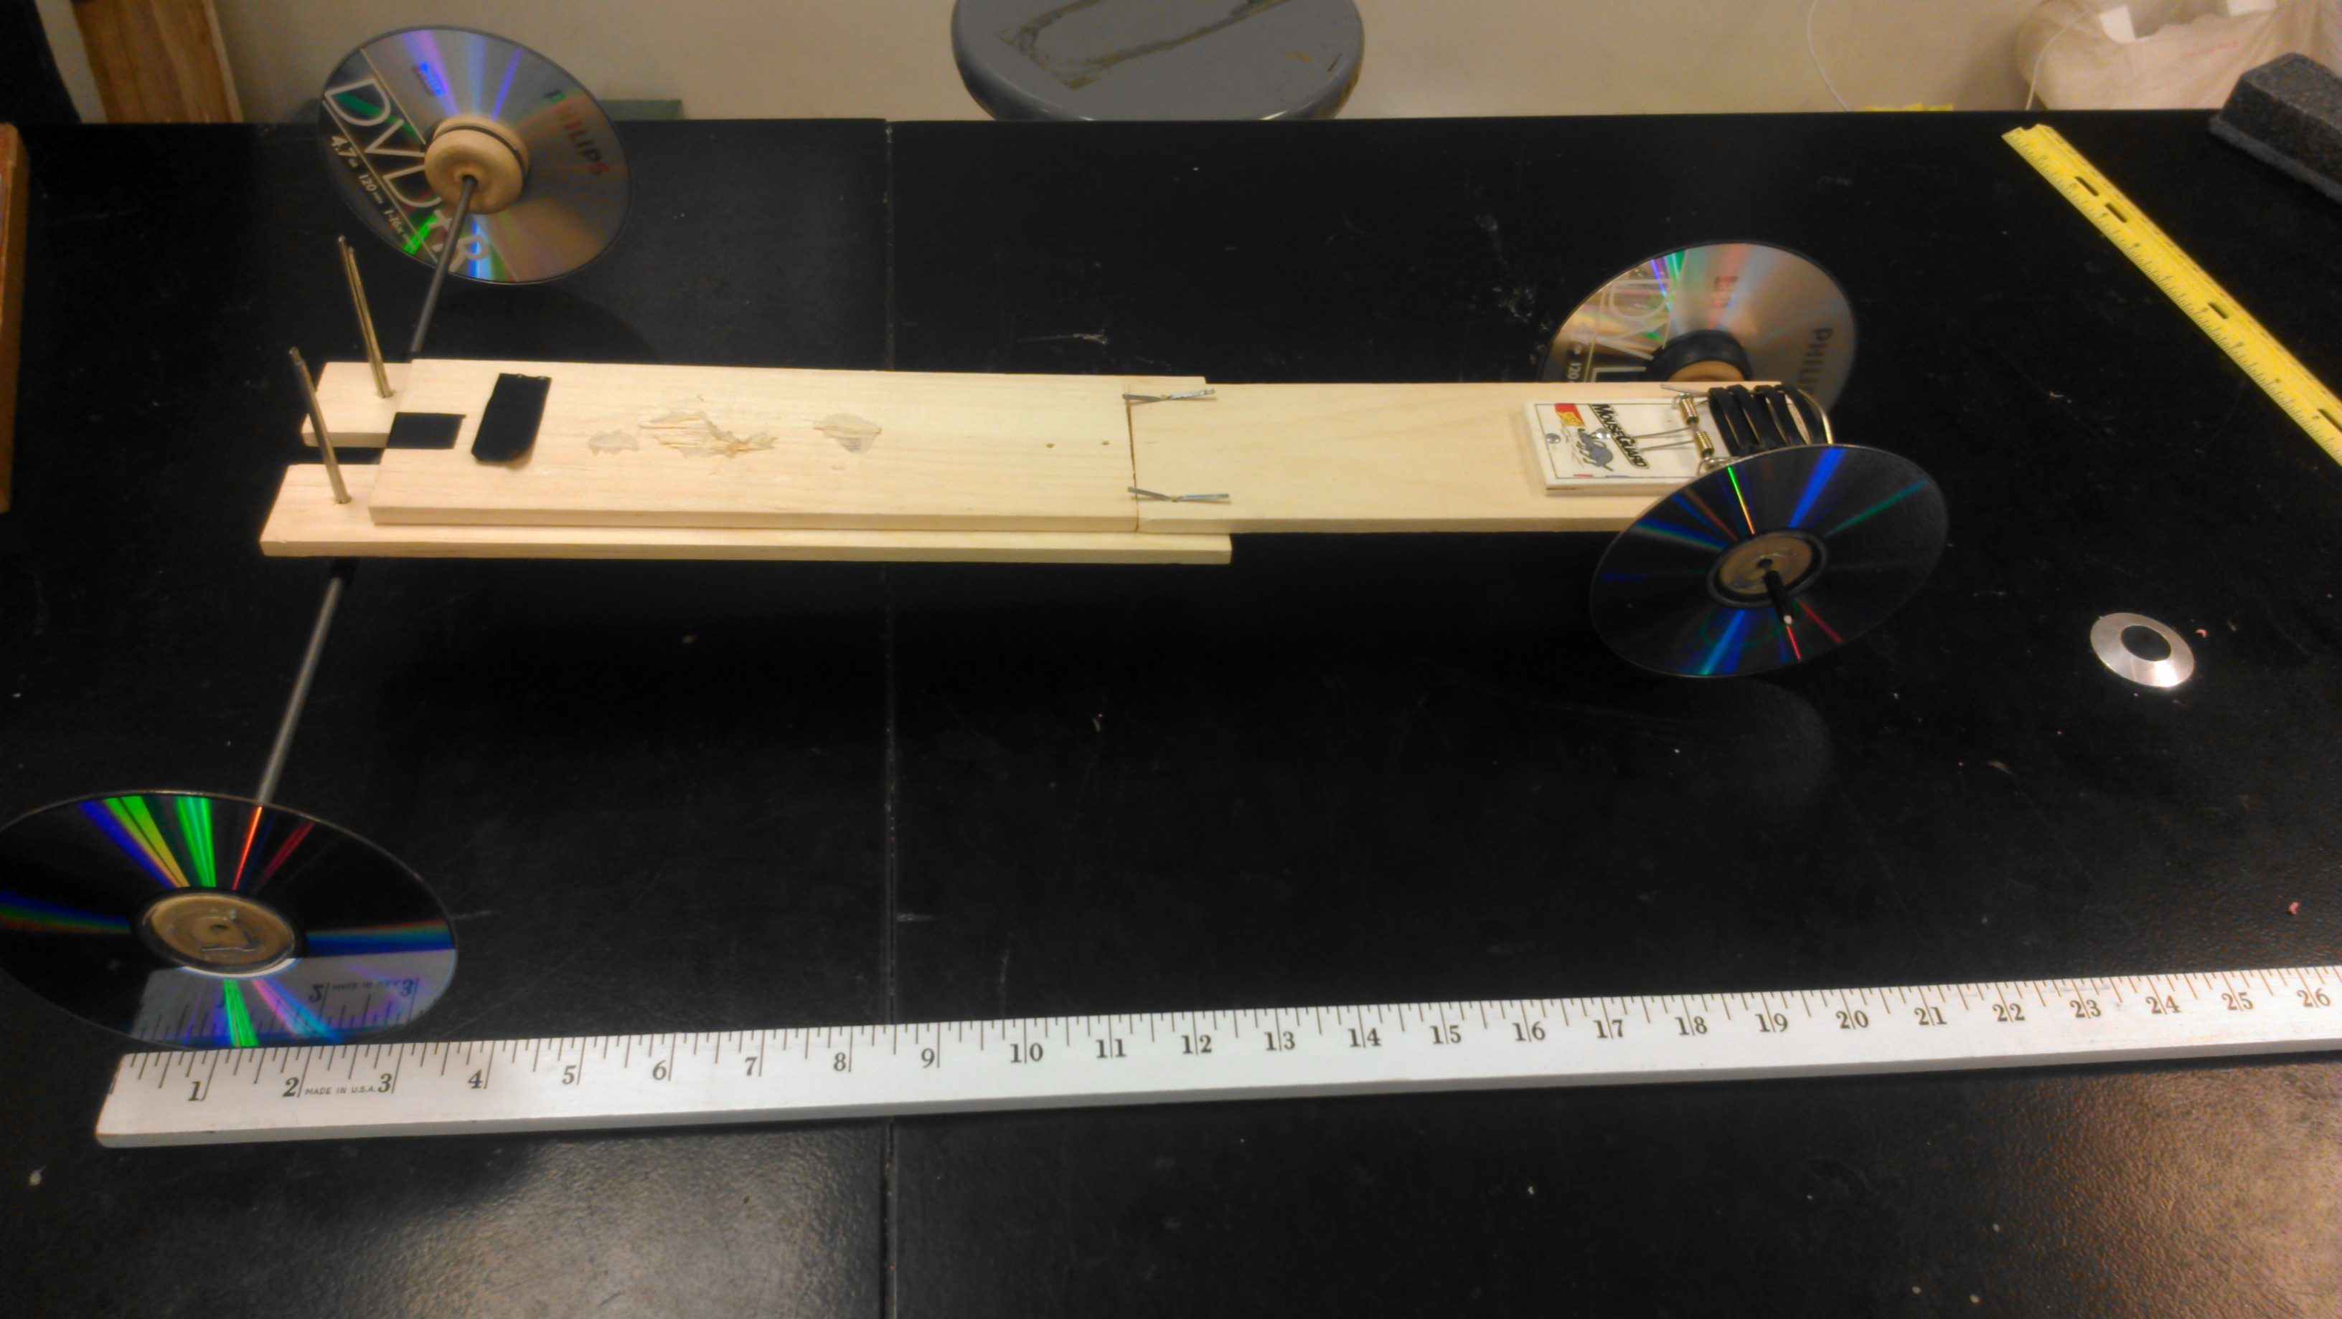 Figure 9

Anecdotally, the teachers found that behavior issues decreased during project involvement. We witnessed increased use of target vocabulary in written work and classroom discussions. There also seemed to be better participation in class discussions. We attribute these gains because the students became active participants in the class and the discovery process and were proud of their work.
This project was not without difficulties. Most of our students had limited access to tools and supplies at home. Many parents lacked background to assist them in this area and students felt isolated due to a lack of adult assistance. The design process can result in increased frustration around failed designs for very impulsive students. These same students as well as others found themselves less interested in redesigning and completing their cars outside of class time. Because this was an authentic learning experience, answers to questions were not a matter of recitation of fact. Some of the car’s failing could not be fixed immediately. They felt frustrated that there were no immediate answers for every problem or question. Some students had difficulty negotiating the sharing of the work both written and manual. Teachers felt that the activity was very time consuming and definitely slowed down the pace of the curriculum. “We covered less material than we have covered in the past. But, what we covered seem to be covered well.”[Teacher]

Conclusion
Most, if not all, of our contentions are supported anecdotally as opposed to statistically. It is difficult to gage the effectiveness of student behavior or interest. The author’s believe that the project concluded in success regarding the engagement of the students in the project based learning model. His opinion is based on a decrease in student referrals and very positive reflections about the project from the students, faculty and administrators. The authors have begun the process of adding other projects into their classes. We will be evaluating the additional implementations with the same lens as this experiment. We anticipate that we shall receive similar feedback and positive experiences for the student learning goals and experiences.

References –
- Massachusetts Department of Secondary Ed. http://profiles.doe.mass.edu/profiles/student.aspx?orgcode=00970505&orgtypecode=6&
- CAPSULE: Capstone Unique learning Experience
- [2011]. A Framework for K-12 Science Education: Practices, crosscutting concepts, and core ideas. [p. 11]. Washington, DC: The National Academies Press. Retrieved from
- https://docs.google.com/a/fitchburg.k12.ma.us/document/d/1hxkX6xueL9VpnSUO1ZAejsHT9ya7Q7XT28fqiPN0WUU
- https://docs.google.com/a/fitchburg.k12.ma.us/document/d/1_7C9x2Cuo62bl2k4bJ1XN6vEPNwXYeyqBX8YOb9gaec/edit#
- https://docs.google.com/a/fitchburg.k12.ma.us/spreadsheet/viewform?formkey=dExHcVdGUU1wdmJScjkyaTI3cDloVWc6MA#gid=0

