MOUSETRAP CAR

DESIGN PROJECT

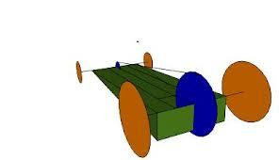

TEAM NAME:

TEAM MEMBERS:

Purpose of project :

Materials List :

(Add spaces if needed)

Steps to Construction of car:

Incorporate your picture on this page. You can scan it into the file or even use google draw to make a representation of your car with dimensions attached. Remember to include a front, top and side view drawing of your car.

Abbreviation and key and terms
Mass - The amount of matter in an object
Radius - The distance from the outside to the center of a circle.

- mfw - mass of forward wheel
- mrw - mass of rear wheel
- mmt - mass of the mouse trap
- mch - mass of the chassis
- mar - mass of the lever arm
- d in front of the letters means distance
- M in front means moments calculated from step 2
- Radius is the distance from the center of the wheel to the outer edge.

You will need to refer to this list above as you complete the lab report.

CALCULATING THE FORCE OF GRAVITY ON THE CAR.

Mass of the:
Forward wheel(s) - _____
Back wheel(s) - _____
Body - _____
Axils- _____
Mouse trap- _____
Lever arm and string _____

Sum all of the above ∑Masses = ______

Using a balance scale, measure the mass of your completed car. _____________

Subtract the two numbers above and the difference has to be all of the tape and glue that you have used to attach all of the parts. _______________

CALCULATING THE FORCE OF GRAVITY ON THE CAR.
The force of gravity on an object is called weight. It is calculated by multiplying the mass times the acceleration of gravity. (9.8m/s²)

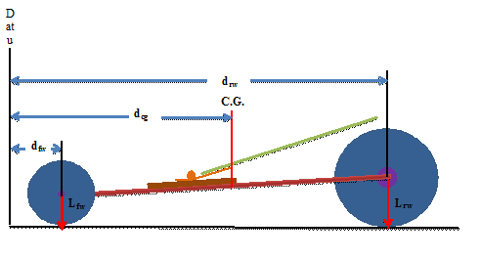

Step 1. Solve for total load (Force due to gravity)
Total weight due to gravity = (total mass * g (g = gravity 9.8 m/s2) _________________)

Step 2. Solve for load at each axle
Load for rw = Weight / distance to rw ______________

Load for fw = Weight / distance to fw ______________

Step 3. Solve for load at each wheel
Load rear wheel = Load for rw / 2 ______________

Load front wheel = Load for fw / 2 ______________

CALCULATING THE MOMENT ON THE CAR.

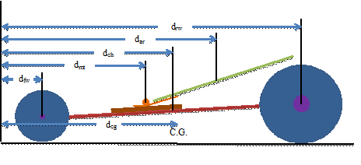

Step 2. Solve for moments of each component
Mfw = dfw * mfw =______________
Mmt = dmt * mmt =______________
Mch = dch * mch =______________
Mar = dar * mar =______________
Mrw = drw * mrw =______________
Step 3. Find summation of moments
∑M = Mfw + Mmt + Mch + Mar + Mrw (Addition of the moments = ________________)

Step 4. Find location of center of Gravity
∑M / ∑m (answer 3/ answer 1 = ________________)

MEASURING THE FORCE OF THE PULL ARM.

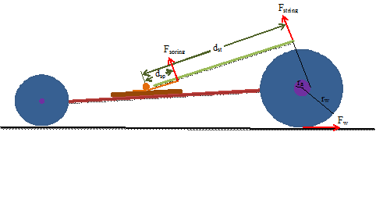

Step 1. Measure the force produced by the spring using a spring scale
Attach a spring scale to end of the mouse trap lever. Pull the lever back while your partner reads the force measure on the scale. Stop at 5 different locations read and record the data. Make sure that the scale is at a right angle to the lever. You may have to adjust the spring scale as you pull. Add the force measures together and find for the average force

_____+______+______+_______+_______= __________/ 5 = _____________

Step 2. Solve torque of spring
Ƭourque of arm = Average force of the spring(answer from 1) * lever arm length = ______________

Step 3. Solve for the tension force in the string
Force of the string = Ƭourque of the arm / length of the string =______________________

Step 4. Solve for the torque at the rear axle
Ƭourque of the axle = Force of the string * radius of the axle = ________________________

Step 5. Solve for the force applied by the wheel to the road surface
Force of the wheel = Ƭourque of the axle / radius of the wheel =________________________

